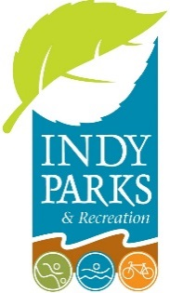 **Agenda**

Board of Parks and Recreation

Consolidated City of Indianapolis

Tuesday, March 18, 2025

City-County Building – T221

200 E. Washington Street, Indianapolis, IN 46204

4:00 PM

**Approval of Minutes**

Approval of February 18, 2025, Park Board Minutes

**New Business**

**Memo No. 9, 2025** – It is the recommendation of the Resource Development Division that the Board of Parks and Recreation approve an amendment to Contract #21079 with Powers & Sons for the MLK Gateway Project at Dr. Martin Luther King Park in the increased amount of $1,888,500, for a new not-to-exceed amount of $6,500,000.

Presented by – Cory Kranek, Construction Administrator, *Indy Parks*

**Memo No. 10, 2025** – It is the recommendation of the Resource Development Division that the Board of Parks and Recreation approve Change Order No. 1 to the JTV Hill Park Renovation with Commercial Contracting Services LLC in the increased amount of $37,882.83 for a new total lump sum amount of $603,832.83. The Change Order adds 60 days to the completion dates, for new Substantial Completion by January 25, 2025, and Final Completion by February 28, 2025.

Presented by – Kevin Thompson, Program Manager Local Projects, *Indy Parks*

**Memo No. 11, 2025** – It is the recommendation of the Department of Parks and Recreation that the Board of Parks and Recreation grant approval of liquor sales with a 210 liquor licenses at Pleasant Run Golf Course and Sarah Shank Golf Course for Ford, Inc & Fored, Inc.

Presented by – Drew Oechsle, Finance & Compliance Analyst, *Indy Parks*

Meeting is Adjourned.

The next Indy Parks Board Meeting is scheduled for April 22, 2025, at 4:00 PM at the City-County Building T221.